**PROJECT REPORT**

Car Sales Analysis

**Name** – Abhishek Satpute

**Project Title** – Car Sales Analysis

**Date** – 13 Jan 2025

**Technology** – Power Bi

**Tools-** Power BI Visualization Tools

### **Project Description:**

This project involves analyzing year-to-date (YTD) car sales data using two dashboards:

1. **Overview Dashboard** - Provides aggregated insights into sales trends, dealership performance, and customer preferences for body styles and colors.
2. **Details Dashboard** - Presents granular data, including car IDs, customer names, sales details, and dealer-specific information for further analysis.

The dashboards aim to support stakeholders in evaluating sales performance and making data-driven decisions to optimize sales strategies and customer engagement.

### **Objectives:**

1. Analyze Year To Date car sales, average prices, and total units sold.
2. Identify trends and patterns in sales across regions, body styles, and colors.
3. Assess the performance of dealerships and manufacturers.
4. Provide detailed, record-level insights for operational and customer-specific analysis.
5. Offer actionable recommendations to enhance business outcomes.

### **Key Performance Indicators (KPIs):**

The dashboard tracks the following KPIs to measure the performance of car sales and dealership efficiency:

#### **1. YTD Total Sales:**

* **Value:** $371.2M
* **Relevance:** Represents the total revenue generated from car sales year-to-date. This metric provides a high-level view of overall performance.
* **Observation:** A year-on-year growth of $70.8M (23.59%) indicates sales growth.

#### **2. YTD Average Price per Car:**

* **Value:** $28.0K
* **Relevance:** Reflects the average selling price of cars. This KPI helps assess pricing strategies and customer affordability trends.
* **Observation:** A slight decline of $0.22K (-0.79%) compared to the previous year suggests possible discounts or shifts to lower-priced models.

#### **3. YTD Cars Sold:**

* **Value:** 13.3K units
* **Relevance:** Represents the total number of units sold.
* **Observation:** A significant increase of 2.62K units (19.73%) highlights growing customer demand.

#### **4. Monthly Trends (MTD):**

* **MTD Total Sales:** $54.28M
* **MTD Average Price:**$28.26K
* **MTD Cars Sold:** 1.92K units



### **Data Summary:**

The dataset includes:

* **Overview Dashboard:**
  + Aggregated metrics for YTD sales, weekly trends, sales by body style, color, and regional dealership performance.
  + Manufacturer-wise performance metrics, including total sales, average price, and growth percentage.
* **Details Dashboard:**
  + Car-specific data, including car IDs, transaction dates, customer names, dealer names, companies, colors, models, and total sales for individual records.

### **Analysis and Findings:**

#### **1] Year-to-Date Sales Weekly Trends:**

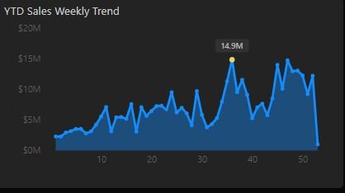

* **Visualization:** Line chart showing weekly sales over the year.
* **Observation:**
  + A significant peak of $14.9M was recorded in week 36, indicating potential seasonal sales spikes.
  + A consistent upward trend is seen in the second half of the year, suggesting increasing demand during that period.

#### **2] Year-to-Date Total Sales by Body Style:**

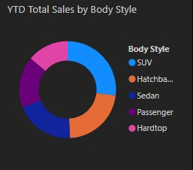

* **Visualization:** Pie chart showing the distribution of sales by body style.
* **Observation:**
  + SUV (26.91%) and Hatchback (22.3%) are the most popular body styles, together accounting for the majority of sales.
  + Sedan(19.85%) cars show comparatively lower contributions.

#### **3] Year-to-Date Total Sales by Color:**

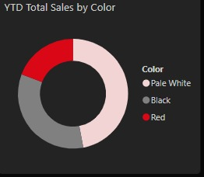

* **Visualization:** Pie chart representing sales distribution by car color.
* **Observation:**
  + Black and Pale White dominate customer preferences, together contributing over 70% of total sales.
  + Red cars account for the smallest share, suggesting limited demand for vibrant colors.

#### **4] Year-to-Date Cars Sold by Dealer Region:**

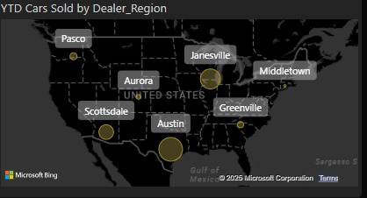

* **Visualization:** Geospatial map highlighting dealer regions and their respective sales contributions.
* **Observation:**
  + Austin and Janesville dealerships outperform others, with significant contributions to total sales.
  + Regions like Greenville and Pasco show relatively lower sales, indicating potential underperformance.

#### **5] Company-Wise Sales Trend:**

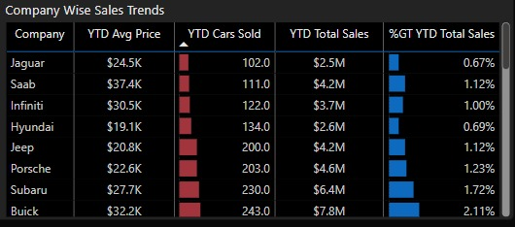

* **Visualization:** Tabular visualization showing company wise average price, cars sold, total sales, and growth percentage for each manufacturer.
* **Observation:**
  + Chevrolet leads in total sales and growth percentage, making it the top-performing manufacturer.
  + Dodge, while achieving higher sales figures, has room for improvement in growth percentage compared to competitors.

### **Details Dashboard Analysis:**

* **Content:** A table displaying granular data for each transaction, including car IDs, transaction dates, customer names, dealer names, companies, colors, models, and total sales.
* **Significance:**
  + Enables record-level tracking of sales for audits and operational insights.
  + Provides insights into customer buying behavior and dealer-specific performance.
  + Facilitates the identification of high-value customers and recurring buyers for targeted marketing.

**SnapShpot:**

**DashBoard**

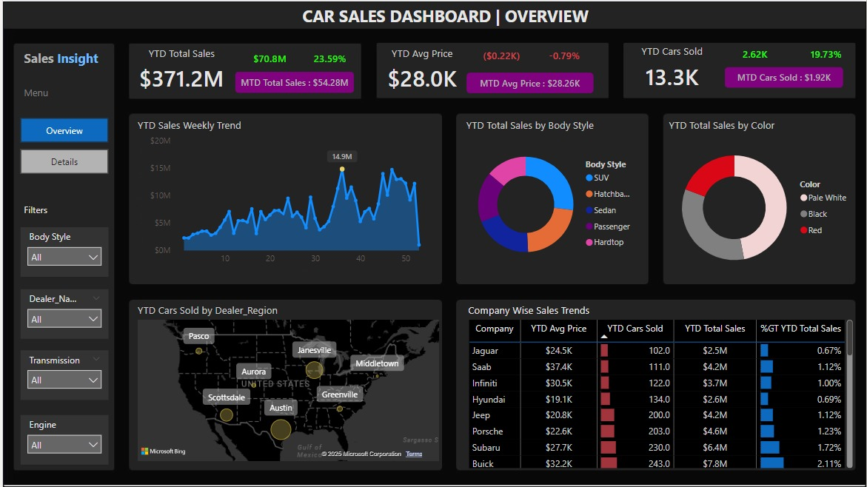

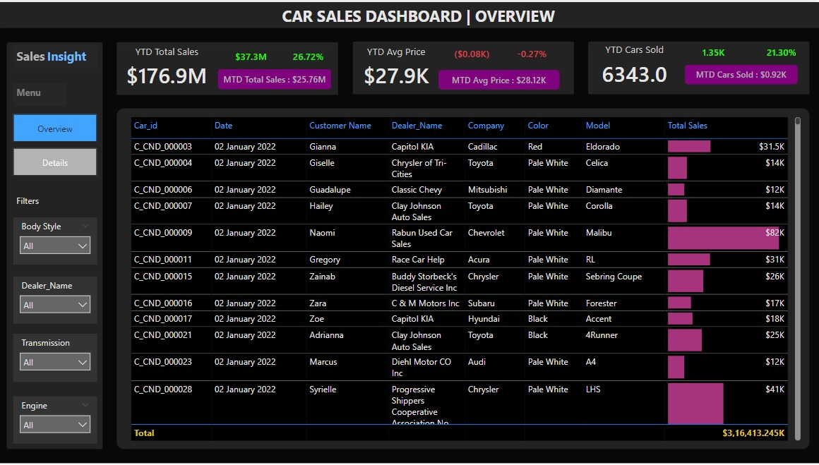

### **Recommendations:**

1. **Focus on High-Performing Regions:**
   * Invest in marketing and inventory optimization in regions like Austin and Janesville.
2. **Boost Popular Body Styles:**
   * Prioritize the production of SUV and Hatchback to meet demand.
3. **Enhance Dealer Support in Low-Performing Regions:**
   * Conduct training and provide resources for dealerships in Middletown and Aurora to improve sales.
4. **Optimize Inventory for Popular Colors:**
   * Ensure sufficient stock of Black and Pale White cars to meet customer preferences.
5. **Encourage Growth for Underperforming Manufacturers:**
   * Collaborate with Dodge and Ford to analyze and address their sales and growth challenges.

### **Conclusion:**

The Car Sales Dashboard project offers comprehensive insights into sales performance, customer preferences, and dealership efficiency. By integrating high-level aggregated insights and granular data, it equips stakeholders to make informed decisions. Future work could focus on incorporating predictive analytics to forecast trends, customer segmentation for personalized marketing, and competitor analysis to enhance the competitive edge.